**Module-1 Assignment**

1. **What is SDLC?**

SDLC is a process that creates a structure of development of software. There are different phases within SDLC, and each phase has its various activities. It makes the development team able to design, create, and deliver a high-quality product.

1. **What is software testing?**

Software testing is a procedure of implementing software or the application to identify the defects or bugs. For testing an application or software, we need to follow some principles to make our product defects free.

1. **What is agile methodology?**

An agile methodology is an iterative approach to software development. Each iteration of agile methodology takes a short time interval of 1 to 4 weeks. The agile development process is aligned to deliver the changing business requirement. It distributes the software with faster and fewer changes.

1. **What is SRS?**

The SRS is a specification for a specific software product, program, or set of applications that perform particular functions in a specific environment. It serves several goals depending on who is writing it. First, the SRS could be written by the client of a system. Second, the SRS could be written by a developer of the system.

1. **What is oops?**

The word **object-oriented** is the combination of two words i.e. **object** and **oriented**. The dictionary meaning of the object is an article or entity that exists in the real world. The meaning of oriented is interested in a particular kind of thing or entity. In layman's terms, it is a programming pattern that rounds around an object or entity are called **object-oriented programming.**

1. **Write basic concept of oops?**

**Object**means a real-world entity such as a pen, chair, table, computer, watch, etc. **Object-Oriented Programming** is a methodology or paradigm to design a program using classes and objects. It simplifies software development and maintenance by providing some concepts:

* [Object](https://www.javatpoint.com/object-and-class-in-java)
* Class
* [Inheritance](https://www.javatpoint.com/inheritance-in-java)
* [Polymorphism](https://www.javatpoint.com/runtime-polymorphism-in-java)
* [Encapsulation](https://www.javatpoint.com/encapsulation)

1. **What is class?**

Collection of objects*is called class. It is a logical entity.*

A class can also be defined as a blueprint from which you can create an individual object. Class doesn't consume any space.

1. **What is object?**

Any entity that has state and behavior is known as an object. For example, a chair, pen, table, keyboard, bike, etc. It can be physical or logical.

An Object can be defined as an instance of a class. An object contains an address and takes up some space in memory.

1. **What is encapsulation?**

Binding (or wrapping) code and data together into a single unit are known as encapsulation. For example, a capsule, it is wrapped with different medicines.

A java class is the example of encapsulation. Java bean is the fully encapsulated class because all the data members are private here.

1. **What is inheritance?**

When one object acquires all the properties and behaviors of a parent object, it is known as inheritance. It provides code reusability. It is used to achieve runtime polymorphism.

1. **What is polymorphism?**

If one task is performed in different ways, it is known as polymorphism. For example: to convince the customer differently, to draw something, for example, shape, triangle, rectangle, etc.

In Java, we use method overloading and method overriding to achieve polymorphism.

Another example can be to speak something; for example, a cat speaks meow, dog barks woof, etc.

1. Draw usecse on online book shoping

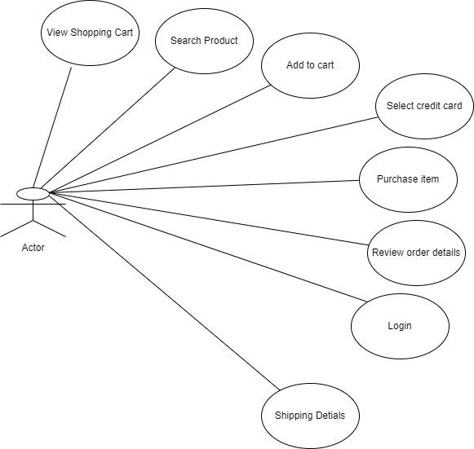

1. **Write SDLC phases with basic introduction?**

A software life cycle model is a pictorial and diagrammatic representation of the software life cycle. A life cycle model represents all the methods required to make a software product transit through its life cycle stages.

**Stage1: Planning and requirement analysis**

The senior members of the team perform it with inputs from all the stakeholders and domain experts or SMEs in the industry.

Planning for the quality assurance requirements and identifications of the risks associated with the projects is also done at this stage.

**Stage2: Defining Requirements**

Once the requirement analysis is done, the next stage is to certainly represent and document the software requirements and get them accepted from the project stakeholders.

This is accomplished through "SRS"- Software Requirement Specification document which contains all the product requirements to be constructed and developed during the project life cycle.

**Stage3: Designing the Software**

The next phase is about to bring down all the knowledge of requirements, analysis, and design of the software project. This phase is the product of the last two, like inputs from the customer and requirement gathering.

**Stage4: Developing the project**

In this phase of SDLC, the actual development begins, and the programming is built. The implementation of design begins concerning writing code. Developers have to follow the coding guidelines described by their management and programming tools like compilers, interpreters, debuggers, etc. are used to develop and implement the code.

**Stage5: Testing**

After the code is generated, it is tested against the requirements to make sure that the products are solving the needs addressed and gathered during the requirements stage.

During this stage, unit testing, integration testing, system testing, acceptance testing are done.

**Stage6: Deployment**

Once the software is certified, and no bugs or errors are stated, then it is deployed.

Then based on the assessment, the software may be released as it is or with suggested enhancement in the object segment.

After the software is deployed, then its maintenance begins.

**Stage7: Maintenance**

Once when the client starts using the developed systems, then the real issues come up and requirements to be solved from time to time.

This procedure where the care is taken for the developed product is known as maintenance.

1. **Explain Phases of waterfall model?**

The steps always follow in this order and do not overlap. The developer must complete every phase before the next phase begins. This model is named "**Waterfall Model**"

**Requirements analysis and specification phase:**

The aim of this phase is to understand the exact requirements of the customer and to document them properly. Both the customer and the software developer work together so as to document all the functions, performance, and interfacing requirement of the software.

**Design Phase:**

This phase aims to transform the requirements gathered in the SRS into a suitable form which permits further coding in a programming language. It defines the overall software architecture together with high level and detailed design. All this work is documented as a Software Design Document (SDD).

**Implementation and unit testing:**

During this phase, design is implemented. If the SDD is complete, the implementation or coding phase proceeds smoothly, because all the information needed by software developers is contained in the SDD.

During testing, the code is thoroughly examined and modified. Small modules are tested in isolation initially. After that these modules are tested by writing some overhead code to check the interaction between these modules and the flow of intermediate output.

**Integration and System Testing:**

This phase is highly crucial as the quality of the end product is determined by the effectiveness of the testing carried out. The better output will lead to satisfied customers, lower maintenance costs, and accurate results. Unit testing determines the efficiency of individual modules. However, in this phase, the modules are tested for their interactions with each other and with the system.

**Operation and maintenance phase:**

 Maintenance is the task performed by every user once the software has been delivered to the customer, installed, and operational.

1. **Write phases of spiral model?**

In this model, we create the application module by module and handed over to the customer so that they can start using the application at a very early stage. And we prepare this model only when the module is dependent on each other. In this model, we develop the application in the stages because sometimes the client gives the requirements in between the process.

* **Requirement analysis**

The spiral model process starts with collecting business needs. In this, the following spirals will include the documentation of system requirements, unit requirements, and the subsystem needs. In this stage, we can easily understand the system requirements because the business analyst and the client have constant communication. And once the cycle is completed, the application will be deployed in the market.

* **Design**

The second stage of the spiral model is designed, where we will plan the logical design, architectural design, flow charts, decision tree, and so on.

* **Coding**

After the compilation of the design stage, we will move to our next step, which is the coding stage. In this, we will develop the product based on the client's requirement and getting the client's feedback as well. This stage refers to the construction of the real application in every cycle.

* **Testing and risk analysis**

Once the development is completed successfully, we will test the build at the end of the first cycle and also analyze the risk of the software on the different aspects such as managing risks, detecting, and observing the technical feasibility. And after that, the client will test the application and give feedback.

1. **Write agile manifesto principles?**

* **Customer Satisfaction** − Highest priority is given to satisfy the requirements of customers through early and continuous delivery of valuable software.
* **Welcome Change** − Changes are inevitable during software development. Ever-changing requirements should be welcome, even late in the development phase. Agile processes should work to increase customers' competitive advantage.
* **Deliver a Working Software** − Deliver a working software frequently, ranging from a few weeks to a few months, considering shorter time-scale.
* **Collaboration** − Business people and developers must work together during the entire life of a project.
* **Motivation** − Projects should be built around motivated individuals. Provide an environment to support individual team members and trust them so as to make them feel responsible to get the job done.
  + **Face-to-face Conversation** − Face-to-face conversation is the most efficient and effective method of conveying information to and within a development team.
  + **Measure the Progress as per the Working Software** − Working software is the key and it should be the primary measure of progress.
  + **Maintain Constant Pace** − Agile processes aim towards sustainable development. The business, the developers, and the users should be able to maintain a constant pace with the project.
  + **Monitoring** − Pay regular attention to technical excellence and good design to enhance agility.
  + **Simplicity** − Keep things simple and use simple terms to measure the work that is not completed.
  + **Self-organized Teams** − An agile team should be self-organized and should not depend heavily on other teams because the best architectures, requirements, and designs emerge from self-organized teams.
  + **Review the Work Regularly** − Review the work done at regular intervals so that the team can reflect on how to become more effective and adjust its behavior accordingly.

**17) Explain working methodology of agile model also write pros and cons**

There are various advantages of using agile methodology over traditional waterfall model or others. Agile development methodology and testing practices have worked wonders for numerous organizations with positive aspects. Its positive aspects are not hidden, it is very much visible in the organization.

Advantages of Agile Methodology

1. Customer satisfaction is rapid, continuous development and delivery of useful software.
2. Customer, Developer, and Product Owner interact regularly to emphasize rather than processes and tools.
3. Product is developed fast and frequently delivered (weeks rather than months.)
4. A face-to-face conversation is the best form of communication.
5. It continuously gave attention to technical excellence and good design.
6. Daily and close cooperation between business people and developers.
7. Regular adaptation to changing circumstances.
8. Even late changes in requirements are welcomed

Disadvantages of Agile methodology:

1. It is not useful for small development projects.
2. There is a lack of intensity on necessary designing and documentation.
3. It requires an expert project member to take crucial decisions in the meeting.
4. Cost of Agile development methodology is slightly more as compared to other development methodology.
5. The project can quickly go out off track if the project manager is not clear about requirements and what outcome he/she wants.
6. Draw use case diagram online shopping using COD

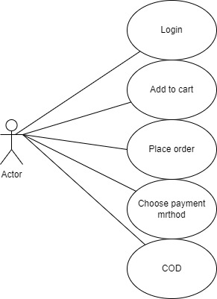

Draw usecase diagram on online shopping product using payment gatway

